January 9, 2013

Mr. Larry Page, CEO
Mr. Eric Schmidt, Chairman
Google Inc.
1600 Amphitheatre Parkway
Mountain View, CA 94043

Dear Messrs. Page and Schmidt:

We just read the news of Google’s and its allies’ campaign to “Go Paperless in 2013.” The campaign website highlights the supposed environmental benefits from such action, http://www.paperless2013.org/.

Contrary to Google’s claims, the use of paper and print on paper isn’t depleting our forests, overwhelming our landfills, or causing global warming. In fact, just the opposite is true—and companies calling for less print or a go-paperless campaign, such as Google’s, don’t take into account that paper, and print on paper, is renewable, recyclable resource, and can be a sustainable way to communicate.

Here are some facts to consider:

Trees and Paper

- Replenished: Wood, which comes from trees, is the primary material used to make paper. Trees are continually replenished—like wheat and corn, unlike plastic—to ensure that our forests are sustainable.

- Primarily Made in the USA: About 90% of paper and paperboard consumed in the United States is produced in the United States.
Dan Burden, "Forest Profile, Agricultural Marketing Resource Center, 2009 (revised by Malinda Geisler, 2011)
http://www.agmrc.org/commodities__products/forestry/forestry-profile/

- High Supplier: 91% of the wood harvested in the United States comes from privately owned forests. State and tribal 6% and federal supply 2%.
American Forest and Paper Association
http://www.afandpa.org/forestry.aspx?id=543

- More Forests Today: forest growth in the United States exceeds harvest by 37%. There is now 28% more standing timber volume in the U.S. than in 1952.
Alaska Forest Facts
http://www.akforest.org/facts.htm

Messrs. Page and Schmidt
January 8, 2013
Page 2

- A Small User of Forest Resources: Just 11% of the world’s forests are used for paper (53% for fuel; 28% for lumber; and 8% for other uses).
International Paper, Down to Earth, Is It Worth Printing?
http://www.internationalpaper.com/Apps/D2E/Down2EarthOnline/pdfs/D2E_7_WorthPrinting.pdf

- Largely Made from “Waste”: Overall, 33% of papermaking material comes from recycled paper; 33 percent comes from wood chips and scrap from sawmills; and 33% comes from virgin trees.
U.S. EPA, Office of Solid Waste
http://www.epa.gov/osw/conserve/materials/paper/faqs.htm#where

Recycling/Landfills

- Recycling: 65.8% of the paper consumed in the U.S. was recovered for recycling in 20101.—by volume, more than glass, plastic and aluminum combined—and up from 33.5% in 1990 and 46% in 2000.
Paper Recycles, http://www.paperrecycles.org

- Landfill: 18.2% of discards into the landfill are paper and paperboard, of which 41% is paperboard containers and packaging and 59% is all other paper—including such items as tissues, paper plates, and paper in games and novelties. Plastics, by comparison, comprise 17.3% of discards.
U.S. EPA, Office of Resource Conservation and Recovery, Municipal Solid Waste Generation, Recycling, and Disposal in the United States, December 2011
http://www.epa.gov/osw/nonhaz/municipal/pubs/2010_MSW_Tables_and_Figures_508.pdf

Often people— and companies like Google—think that by foregoing print and paper, they are saving trees and making a sound environmental choice. In reality, the opposite is true.

As Dr. Patrick Moore, Co-Founder, Greenpeace/Chair & Chief Scientist, Greenspirit Strategies Inc. said: “To address climate change, we must use more wood, not less. Using wood sends a signal to the marketplace to grow more trees and to produce more wood. That means we can then use less concrete, steel and plastic -- heavy carbon emitters through their production. Trees are the only abundant, biodegradable and renewable global resource.”
Greenspirit, http://www.greenspirit.com/logbook.cfm?msid=169

Google’s campaign smacks of greenwashing. Let’s hope it’s unintentional. Google—and its coalition allies—need to focus on the environment impact of electronic media before pointing a finger at the environmental impact of paper—and by implication print on paper.

We encourage Google to reconsider its participation in this campaign.
Sincerely,
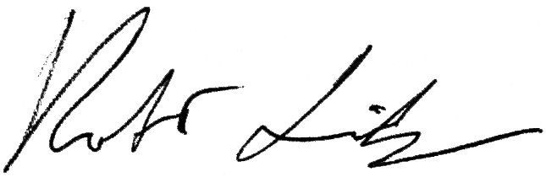
Robert Lindgren, President

P.S. Learn More at http://www.chooseprint.org

